Jimi Porter

CIS 310-01

Due 09/01/2019

**Chapter 1 Homework**

**1.** The file contains 7 records and there are 5 fields.

**2.** The problem you would encounter if you wanted to produce a listing by city is you would have to separate the city from the address to produce a field that contains the cities. You would solve this problem by making another field for the cities in the records.

**3.**You would alter the file structure by making fields for the last name, area code, city, state, and zip code, this produces the new file structure separated in the way we wish.

**4.** Data redundancies I detect are the records for Holly B. Parker and George F. Dorts, these records appear numerous times instead of once. These redundancies lead to anomalies by having the opportunity to represent false data within the record.

**5.** The serious data redundancy problems are the repeated objects within a field that leads to numerous records showing data that is otherwise inefficient and not very clear to the idea. An example is the repeated employee names like John D. Newson. The solution to this problem would be separate tables for the project number/name, or a relational database with foreign and primary keys that help with the clarity of the table.

**11**. **A + B)**

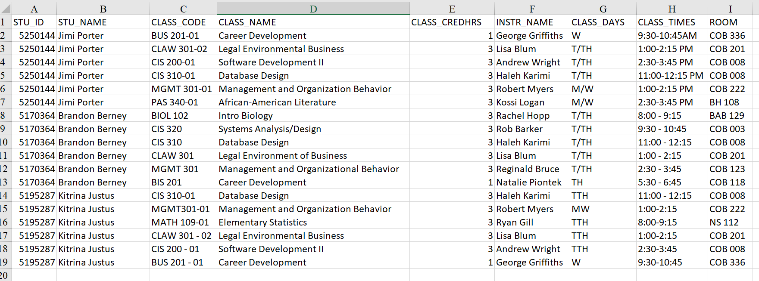

**C)** The redundancies in this design are the repetition of the objects within each field. Anomalies are caused by altering information that doesn’t update elsewhere in the design leading to incorrect and false data. This could be solved by splitting tables and using a database with primary and foreign keys.